EC5070 DATABASE SYSTEMS

LAB 02

WIMALASOORIYA G.H.N.P.D.

2022/E/039

GROUP CG03

SEMESTER 05

2 MAY 2025

***TASK 01***

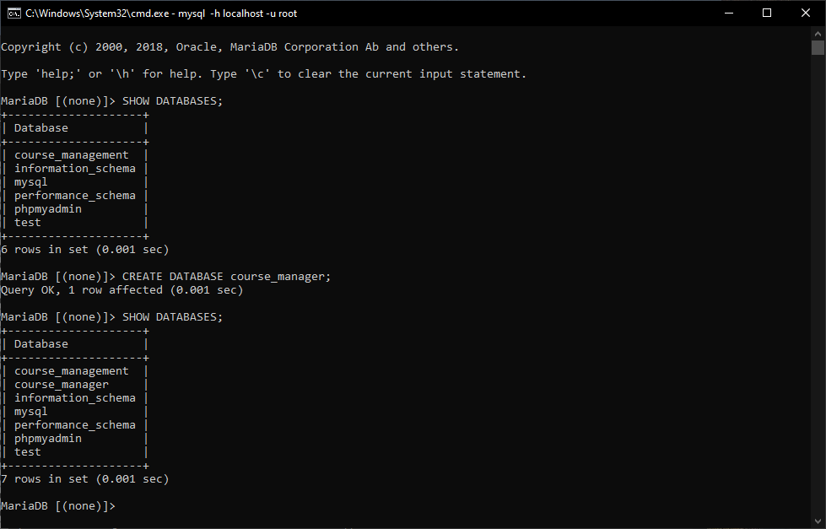

FIGURE 01: CONNECT TO THE MySQL



FIGURE 02: VIEW ALL DATABASES ON YOUR LOCALHOST.



FIGURE 03: CREATE A DATABASE COURSE_MANAGER.

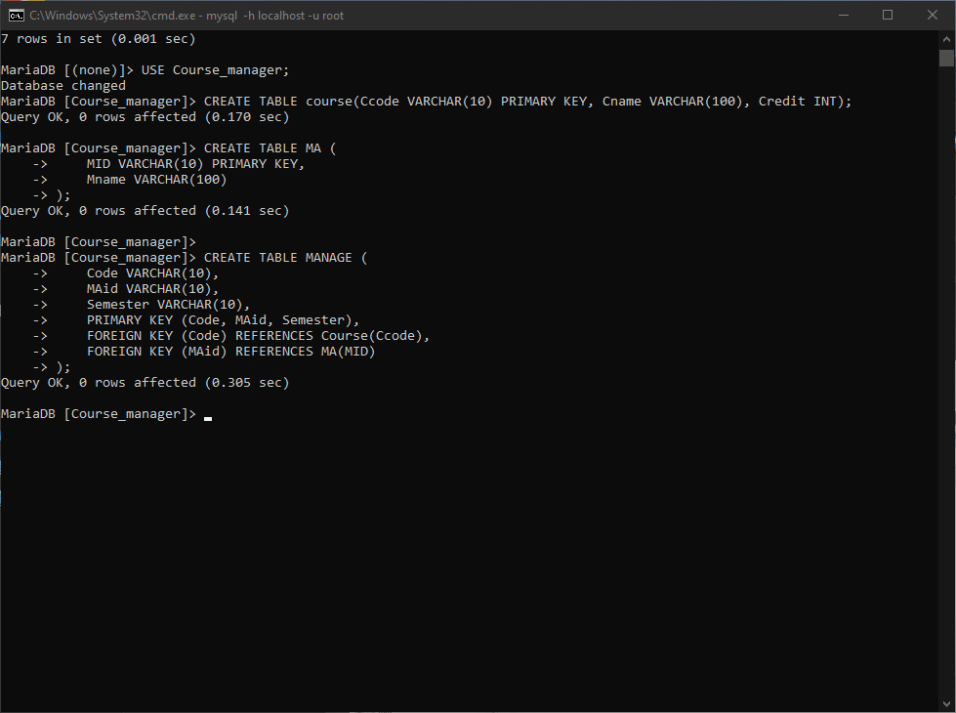

FIGURE 04: SELECT OR ACCESS A DATABASE USING ‘USE’ COMMAND.



FIGURE 05: CREATE NECESSARY TABLES.

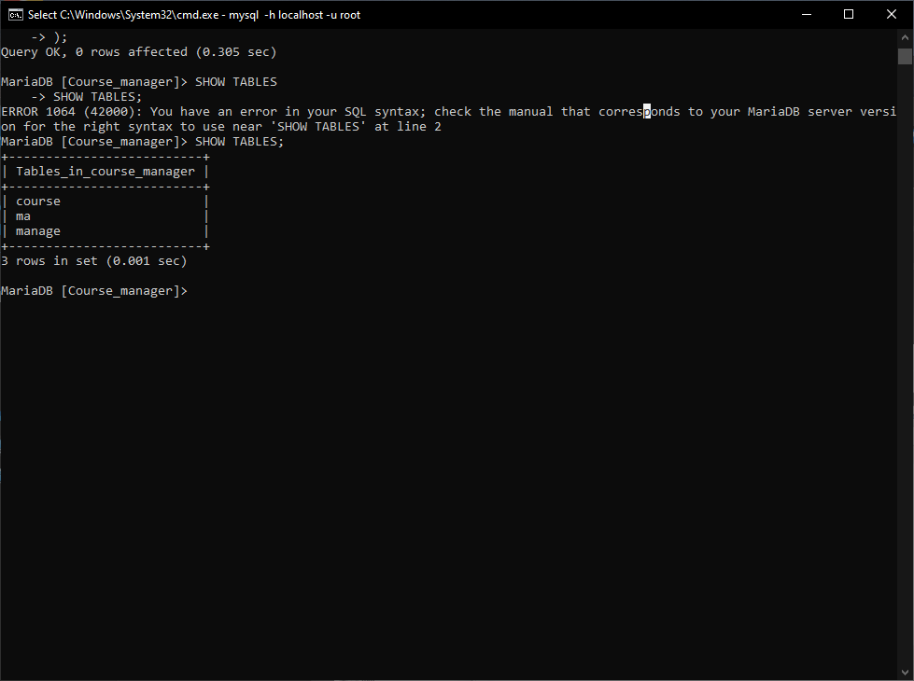

FIGURE 06: VIEW TABLES IN THE COURSE_MANAGER DATABASE

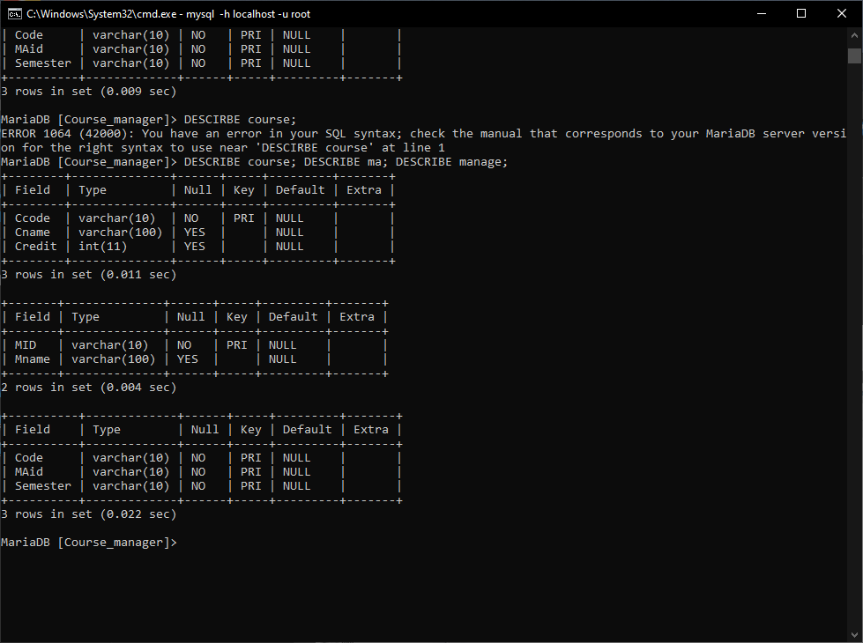

FIGURE 07: VIEW TABLE STRUCTURE

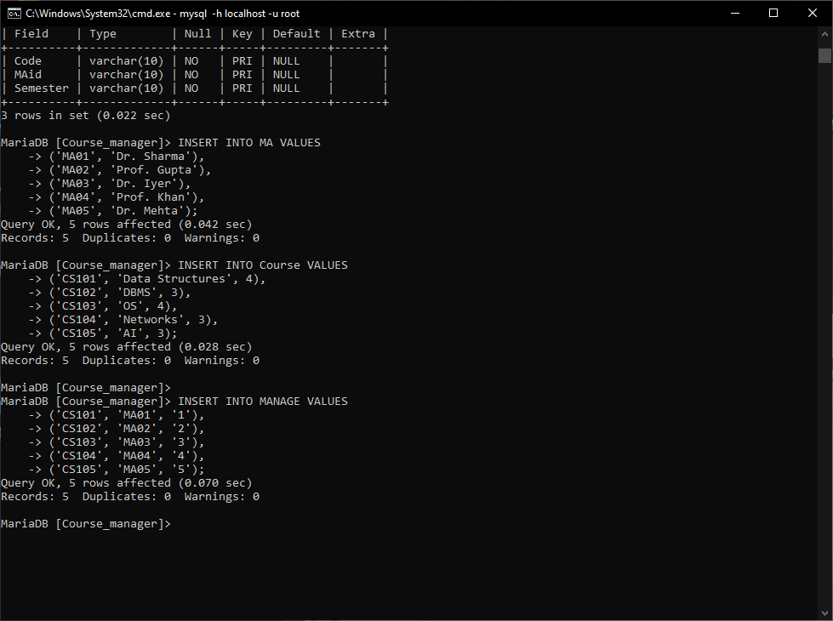

FIGURE 08: INSERT FIVE DIFFERENT MAS WHO HANDLE FIVE DIFFERENT SEMESTERS (FILL THREE TABLES).



FIGURE 09: INSERT FIVE DIFFERENT COURSES FOR FIVE DIFFERENT SEMESTERS (FILL THREE TABLES).

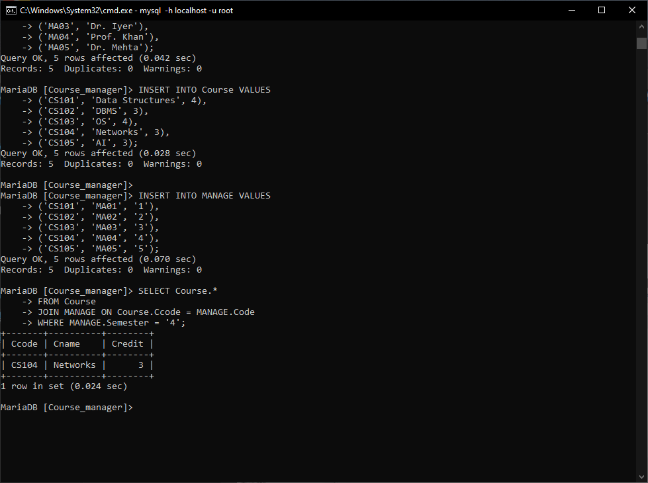

FIGURE 10: LIST THE COURSE DETAILS OF SEMESTER 4 (ONE OF THE SEMESTER).

***TASK 02***

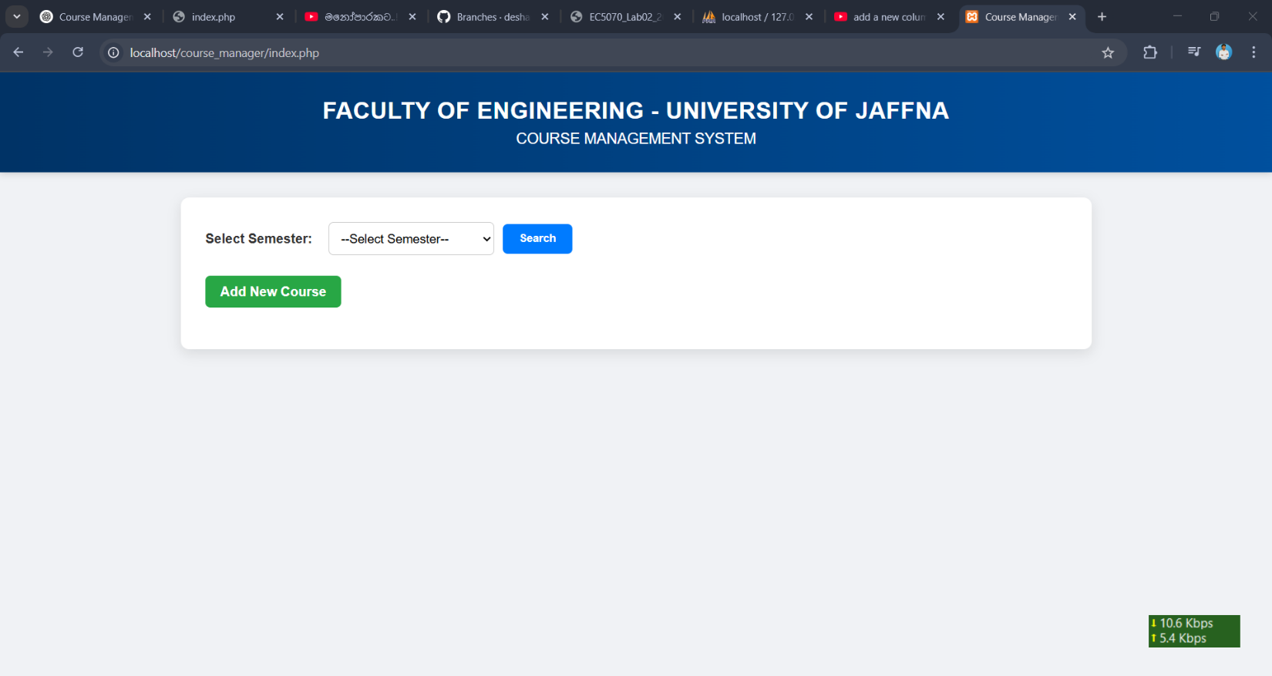

FIGURE 10: MAIN PAGE

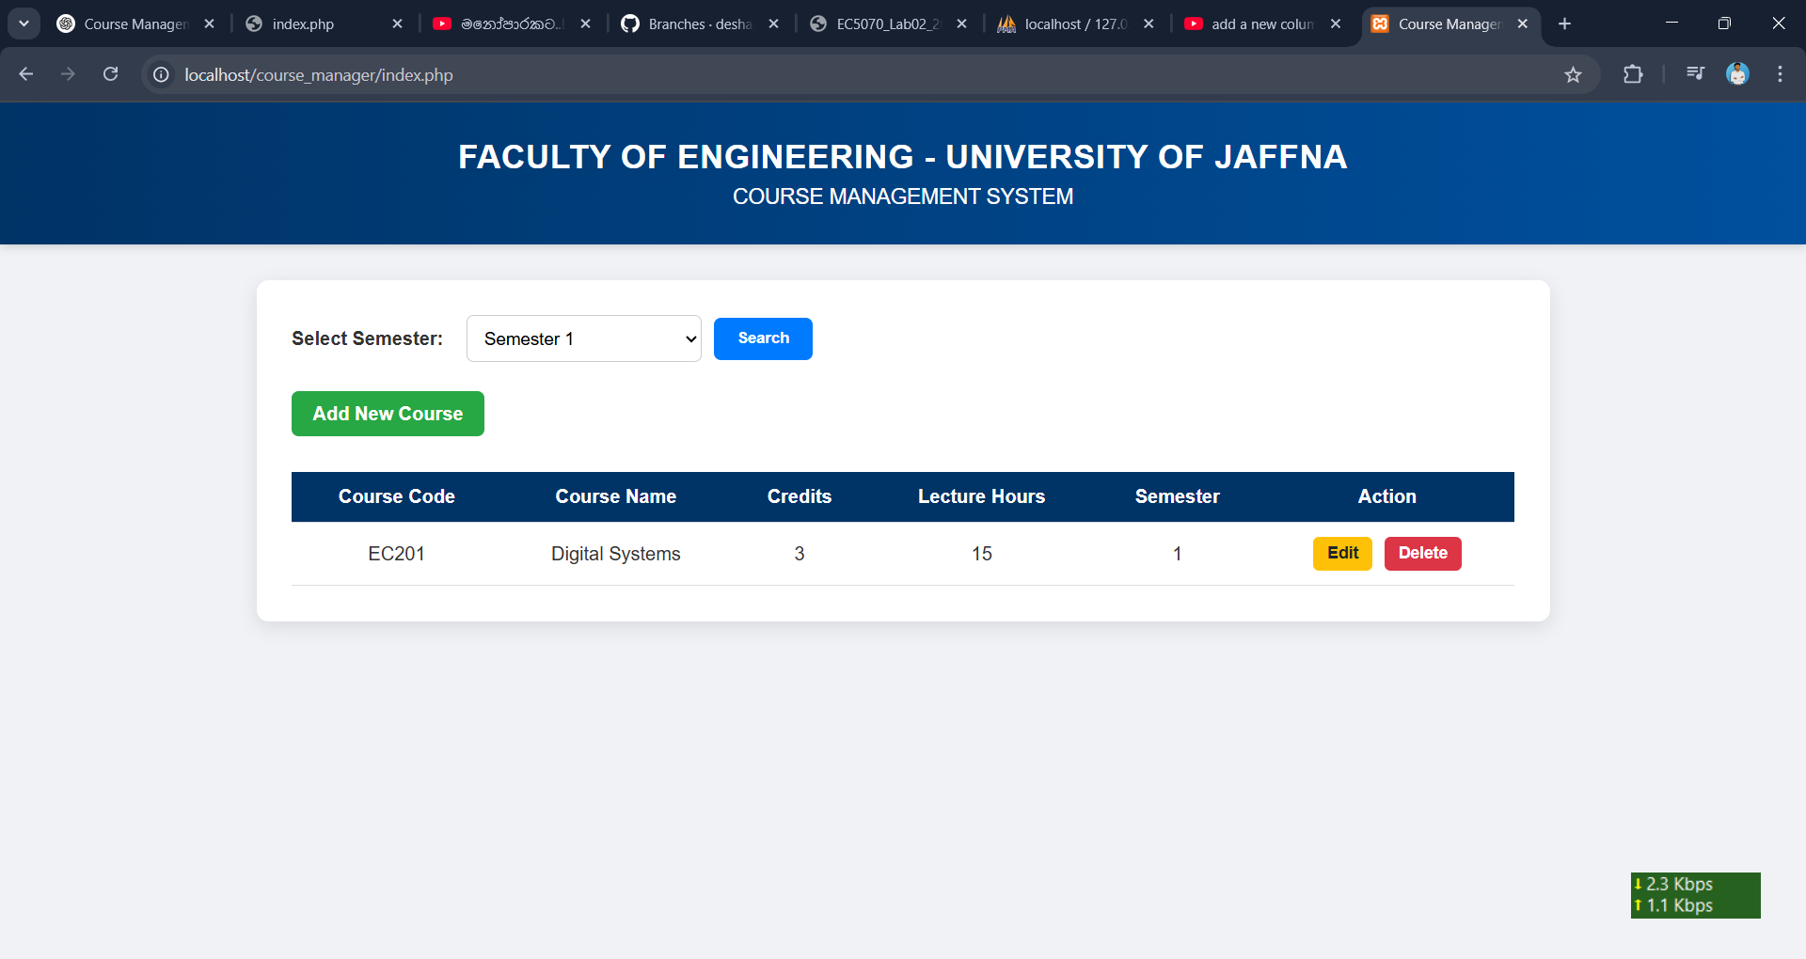

FIGURE 11: SEARCH A COURSE BY SEMESTER

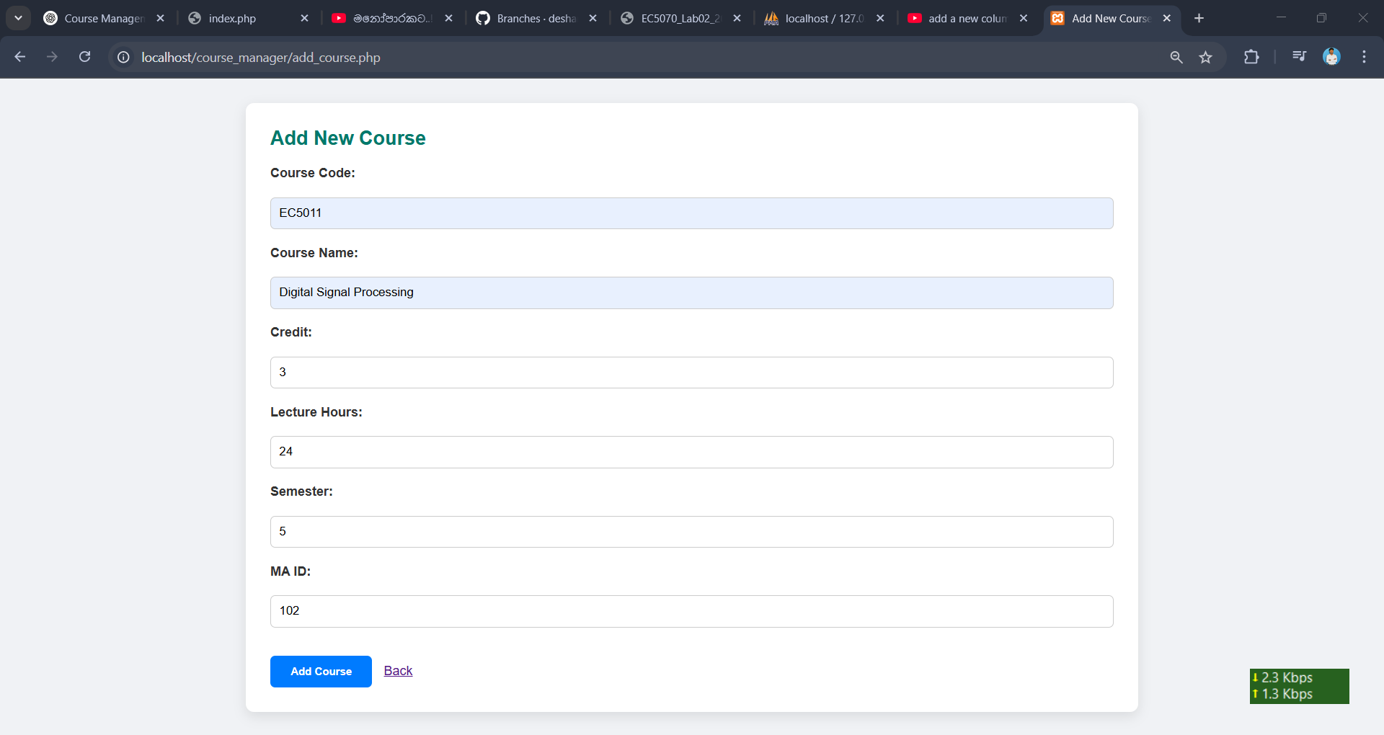

FIGURE 12: ADD A NEW COURSE

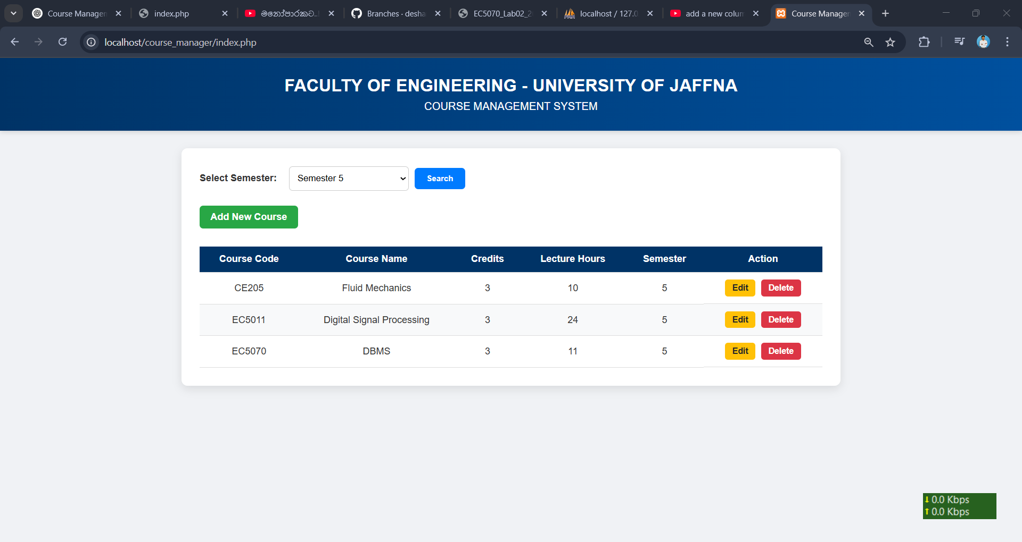

FIGURE 13: AFTER ADD A NEW COURSE

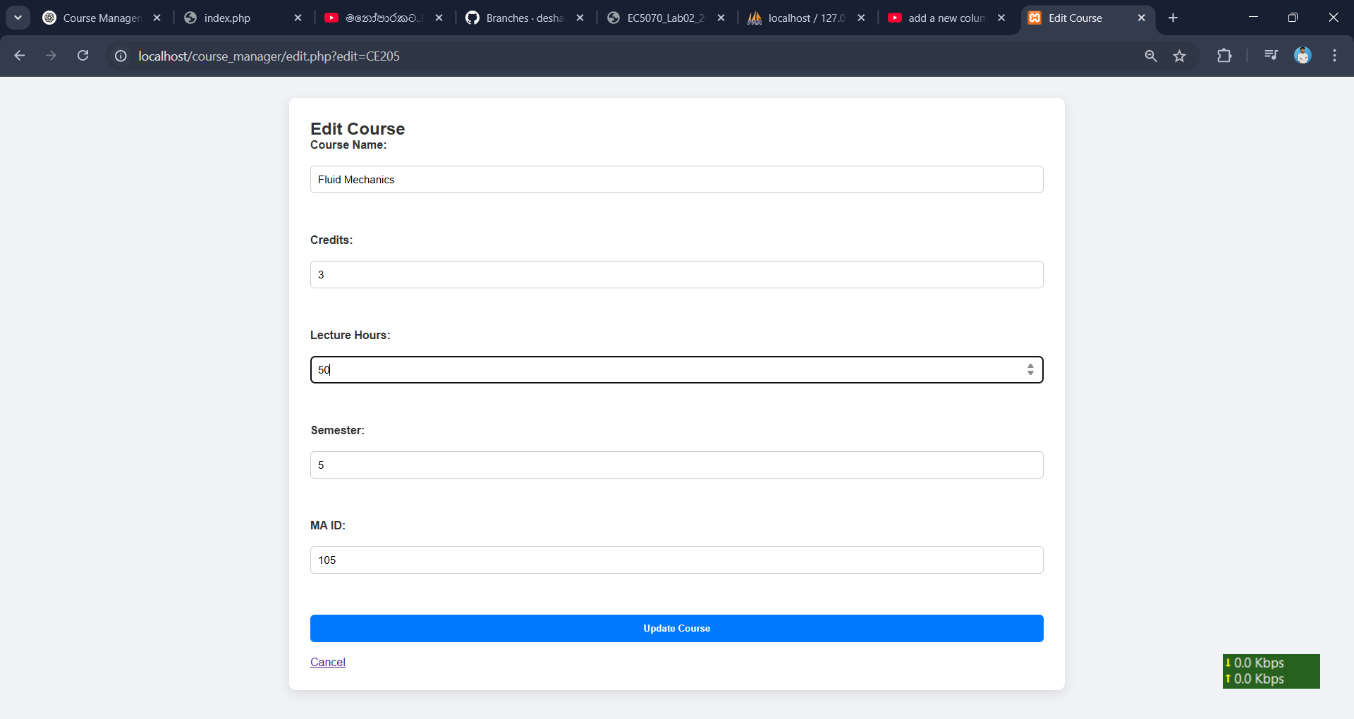

FIGURE 14: EDIT A COURSE (LECTURE HOURSE)

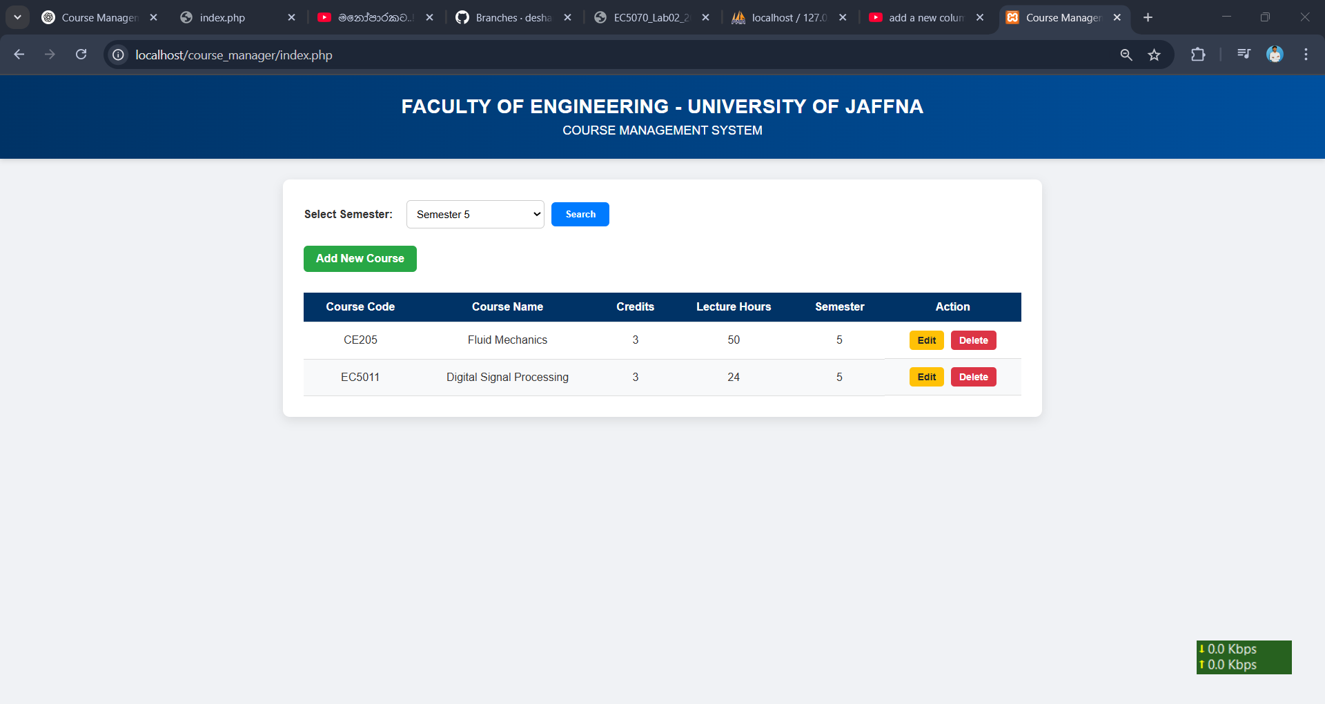

FIGURE 15: AFTER EDIT A COURSE

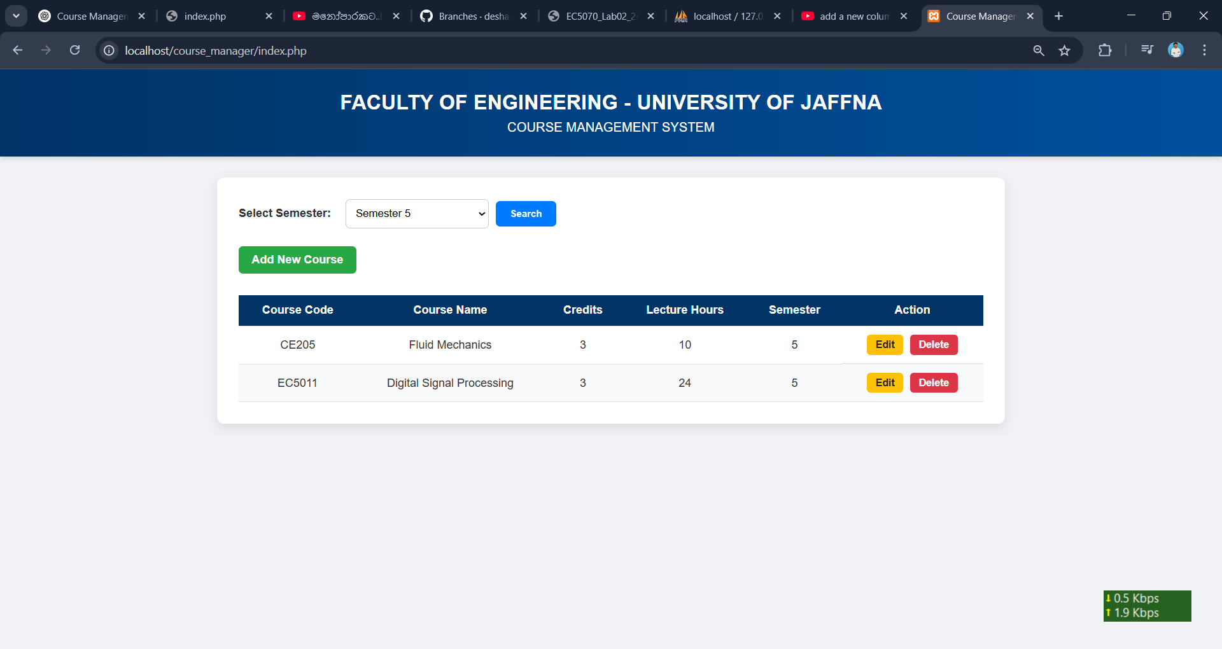

FIGURE 16: DELETE A COURSE